Supplementary Materials

Table S1: International Cartilage Repair Society (ICRS) Grading.
ICRS Grade | Description
0 (Normal) | No lesions fissures or cracks.
1 (Nearly Normal) | Superficial lesions. Soft indentation and/or superficial fissures and cracks.
2 (Abnormal) | Lesions extending down to <50% of cartilage depth.
3 (Severely Abnormal) | Cartilage defects extending down >50% of cartilage depth as well as down to calcified layer and down to but not through the subchondral bone. Blisters are included in this Grade.
4 (Severely Abnormal) | Cartilage defects extending down >75% of cartilage depth as well as down to calcified layer and through the subchondral bone. Blisters are included in this Grade.

Table S2: Cadaver demographics.
 | Age | Gender | Race | Height (cm) | Weight (kg) | BMI | Cause of Death
Cadaver 1 | 31 | Female | Not known | 172.7 | 47.2 | 15.81 | Cardiac arrest
Cadaver 2 | 37 | Female | White | 160.0 | 79.4 | 31.00 | Intracerebral haemorrhage; Severe hypertension
Cadaver 3 | 43 | Female | White | 170.2 | 64.4 | 22.24 | Metastatic cervical carcinoma
Cadaver 4 | 49 | Male | White | 175.3 | 58.5 | 19.05 | Not known
Cadaver 5 | 51 | Male | White | 182.9 | 104.3 | 31.19 | Cardiac arrhythmia; Coronary artery disease
Cadaver 6 | 58 | Male | White | 188.0 | 84.8 | 24.01 | Gunshot wound of head and neck
Cadaver 7 | 72 | Male | Puerto Rican | 162.6 | 70.3 | 26.60 | Atherosclerotic heart disease of native coronary
Cadaver 8 | 72 | Male | White | 167.6 | 72.6 | 25.82 | Debility; Alzheimer's disease
Cadaver 9 | 79 | Male | White | 172.7 | 72.1 | 24.17 | Acute myocardial infarction; Coronary artery disease
Cadaver 10 | 80 | Male | White | 182.9 | 83.9 | 25.09 | Myocardial infarction; Cardiac arrest; Hypertension
Cadaver 11 | 86 | Female | White | 165.1 | 63.5 | 23.29 | Respiratory failure; Pneumonia
Cadaver 12 | 88 | Male | White | 177.8 | 68.0 | 21.52 | Natural causes; Unspecified

Table S3: Kruskal-Wallis one-way ANOVA results, showing asymptotic significance (Asymp. Sig.) in chi-square with specified degrees of freedom (df) for the anterior (ACL) and posterior (PCL) cruciate ligaments, medial (MCL) and lateral (LCL) collateral ligaments material property data. ABREVIATIONS: $L_{0}$, original length of the ligament; $CSA$, cross-sectional area; $F$, force or load; $σ$, stress; $ε$, strain at the maximum point of the linear region (_{max linear}) and failure (_{failure}) point of the load-extension curve; $E_{secant}$, secant modulus; $E_{tan}$, tangent modulus; $k$, stiffness. *Significant at p≤0.05.
 |  | $F_{max linear}$ (N) | $σ_{max linear}$ (MPa) | Max Linear Extension (mm) | $ε_{\max{linear}}$ (%) | $E_{secant}$ (MPa) | $E_{tan}$ (MPa) | $F_{failure}$ (N) | $$σ_{failure}$$  (MPa) | Failure extension (mm) | $ε_{failure}$ (%) | $k$ (N/mm)
ACL | Chi-Square | 6.846* | 3.923 | 7.615* | 4.027 | 3.154 | 2.577 | 3.808 | 3.769 | 6.179* | 3.103 | 3.513
ACL | df | 2 | 2 | 2 | 2 | 2 | 2 | 2 | 2 | 2 | 2 | 2
ACL | Asymp. Sig. | 0.033 | 0.141 | 0.022 | 0.134 | 0.207 | 0.276 | 0.149 | 0.152 | 0.046 | 0.212 | 0.173
PCL | Chi-Square | 2.577 | 2.128 | 1.308 | 1.665 | 3.154 | 3.808 | 1.654 | 2.077 | 1.042 | 5.551 | 2.577
PCL | df | 2 | 2 | 2 | 2 | 2 | 2 | 2 | 2 | 2 | 2 | 2
PCL | Asymp. Sig. | 0.276 | 0.345 | 0.520 | 0.435 | 0.207 | 0.149 | 0.437 | 0.354 | 0.594 | 0.062 | 0.276
MCL | Chi-Square | 2.76 | 2.373 | 0.893 | 4.093 | 2.16 | 3.133 | 0.573 | 2.333 | 0.454 | 0.84 | 0.773
MCL | df | 2 | 2 | 2 | 2 | 2 | 2 | 2 | 2 | 2 | 2 | 2
MCL | Asymp. Sig. | 0.252 | 0.305 | 0.640 | 0.129 | 0.340 | 0.209 | 0.751 | 0.311 | 0.797 | 0.657 | 0.679
LCL | Chi-Square | 1.462 | 1.038 | 1.141 | 1.476 | 0.731 | 1.103 | 2.885 | 2.885 | 2.744 | 1.103 | 2.577
LCL | df | 2 | 2 | 2 | 2 | 2 | 2 | 2 | 2 | 2 | 2 | 2
LCL | Asymp. Sig. | 0.482 | 0.595 | 0.565 | 0.478 | 0.694 | 0.576 | 0.236 | 0.236 | 0.254 | 0.576 | 0.276

Table S4: Kendall’s Tau-b ($τ_{b}$) correlation coefficient and their statistically significant (Sig.) values for the anterior (ACL) and posterior (PCL) cruciate ligaments, medial (MCL) and lateral (LCL) collateral ligaments material property data. ABREVIATIONS: N, specimen number; OA ICRS, osteoarthritis International Cartilage Repair Society; $L_{0}$, original length of the ligament; $CSA$, cross-sectional area; $F$, force or load; $σ$, stress; $ε$, strain at the maximum point of the linear region (_{max linear}) and failure (_{failure}) point of the load-extension curve; $E_{secant}$, secant modulus; $E_{tan}$, tangent modulus; $k$, stiffness. *Correlation is significant at the 0.05 level (2-tailed). **Correlation is significant at 0.01 level (2-tailed).
 |  |  | Age | OA ICRS Grade | $F_{max linear}$ (N) | $σ_{max linear}$ (MPa) | Max Linear Extension (mm) | $ε_{\max{linear}}$ (%) | $E_{secant}$ (MPa) | $E_{tan}$ (MPa) | $F_{failure}$ (N) | $$σ_{failure}$$  (MPa) | Failure Extension (mm) | $ε_{failure}$ (%) | $k$ (N/mm)
ACL | Age | $$τ_{b}$$ | 1.000 | .663** | -.626** | -.473* | -.443* | -0.277 | -0.412 | -0.382 | -.504* | -.534* | -.534* | -0.412 | -0.382
ACL | Age | Sig. (2-tailed) |  | 0.005 | 0.005 | 0.033 | 0.046 | 0.215 | 0.063 | 0.086 | 0.023 | 0.016 | 0.016 | 0.063 | 0.086
ACL | Age | N | 12 | 12 | 12 | 12 | 12 | 12 | 12 | 12 | 12 | 12 | 12 | 12 | 12
ACL | OA ICRS Grade | $$τ_{b}$$ | .663** | 1.000 | -.461* | -.526* | -.592* | -.497* | -0.395 | -0.362 | -0.197 | -0.362 | -0.263 | -0.132 | -0.197
ACL | OA ICRS Grade | Sig. (2-tailed) | 0.005 |  | 0.048 | 0.024 | 0.011 | 0.034 | 0.090 | 0.120 | 0.397 | 0.120 | 0.259 | 0.572 | 0.397
ACL | OA ICRS Grade | N | 12 | 12 | 12 | 12 | 12 | 12 | 12 | 12 | 12 | 12 | 12 | 12 | 12
PCL | Age | $$τ_{b}$$ | 1.000 | .663** | -0.412 | -0.382 | -0.229 | -0.140 | -.504* | -.534* | -0.321 | -0.382 | 0.031 | -0.076 | -0.412
PCL | Age | Sig. (2-tailed) |  | 0.005 | 0.063 | 0.086 | 0.303 | 0.534 | 0.023 | 0.016 | 0.149 | 0.086 | 0.890 | 0.731 | 0.063
PCL | Age | N | 12 | 12 | 12 | 12 | 12 | 12 | 12 | 12 | 12 | 12 | 12 | 12 | 12
PCL | OA ICRS Grade | $$τ_{b}$$ | .663** | 1.000 | -0.197 | -0.164 | -0.066 | -0.017 | -0.296 | -0.329 | -0.164 | -0.230 | 0.149 | -0.033 | -0.263
PCL | OA ICRS Grade | Sig. (2-tailed) | 0.005 |  | 0.397 | 0.480 | 0.778 | 0.943 | 0.204 | 0.158 | 0.480 | 0.323 | 0.524 | 0.888 | 0.259
PCL | OA ICRS Grade | N | 12 | 12 | 12 | 12 | 12 | 12 | 12 | 12 | 12 | 12 | 12 | 12 | 12
MCL | Age | $$τ_{b}$$ | 1.000 | .759** | -0.085 | -0.197 | 0.141 | 0.085 | -0.366 | -0.366 | -0.197 | -0.310 | -0.057 | -0.141 | -0.310
MCL | Age | Sig. (2-tailed) |  | 0.007 | 0.753 | 0.463 | 0.600 | 0.753 | 0.173 | 0.173 | 0.463 | 0.249 | 0.833 | 0.600 | 0.249
MCL | Age | N | 9 | 9 | 9 | 9 | 9 | 9 | 9 | 9 | 9 | 9 | 9 | 9 | 9
MCL | OA ICRS Grade | $$τ_{b}$$ | .759** | 1.000 | -0.210 | -0.269 | -0.150 | -0.210 | -0.269 | -0.269 | -0.090 | -0.210 | -0.121 | -0.269 | -0.090
MCL | OA ICRS Grade | Sig. (2-tailed) | 0.007 |  | 0.451 | 0.333 | 0.590 | 0.451 | 0.333 | 0.333 | 0.747 | 0.451 | 0.665 | 0.333 | 0.747
MCL | OA ICRS Grade | N | 9 | 9 | 9 | 9 | 9 | 9 | 9 | 9 | 9 | 9 | 9 | 9 | 9
LCL | Age | $$τ_{b}$$ | 1.000 | .663** | -0.321 | -0.290 | -0.137 | -0.308 | -0.137 | -0.168 | -0.412 | -0.198 | -0.015 | -0.168 | -.443*
LCL | Age | Sig. (2-tailed) |  | 0.005 | 0.149 | 0.192 | 0.536 | 0.168 | 0.536 | 0.450 | 0.063 | 0.372 | 0.945 | 0.450 | 0.046
LCL | Age | N | 12 | 12 | 12 | 12 | 12 | 12 | 12 | 12 | 12 | 12 | 12 | 12 | 12
LCL | OA ICRS Grade | $$τ_{b}$$ | .663** | 1.000 | -0.164 | -0.263 | 0.066 | -0.182 | -0.263 | -0.296 | -0.296 | -.461* | -0.099 | -0.263 | -0.230
LCL | OA ICRS Grade | Sig. (2-tailed) | 0.005 |  | 0.480 | 0.259 | 0.778 | 0.436 | 0.259 | 0.204 | 0.204 | 0.048 | 0.672 | 0.259 | 0.323
LCL | OA ICRS Grade | N | 12 | 12 | 12 | 12 | 12 | 12 | 12 | 12 | 12 | 12 | 12 | 12 | 12

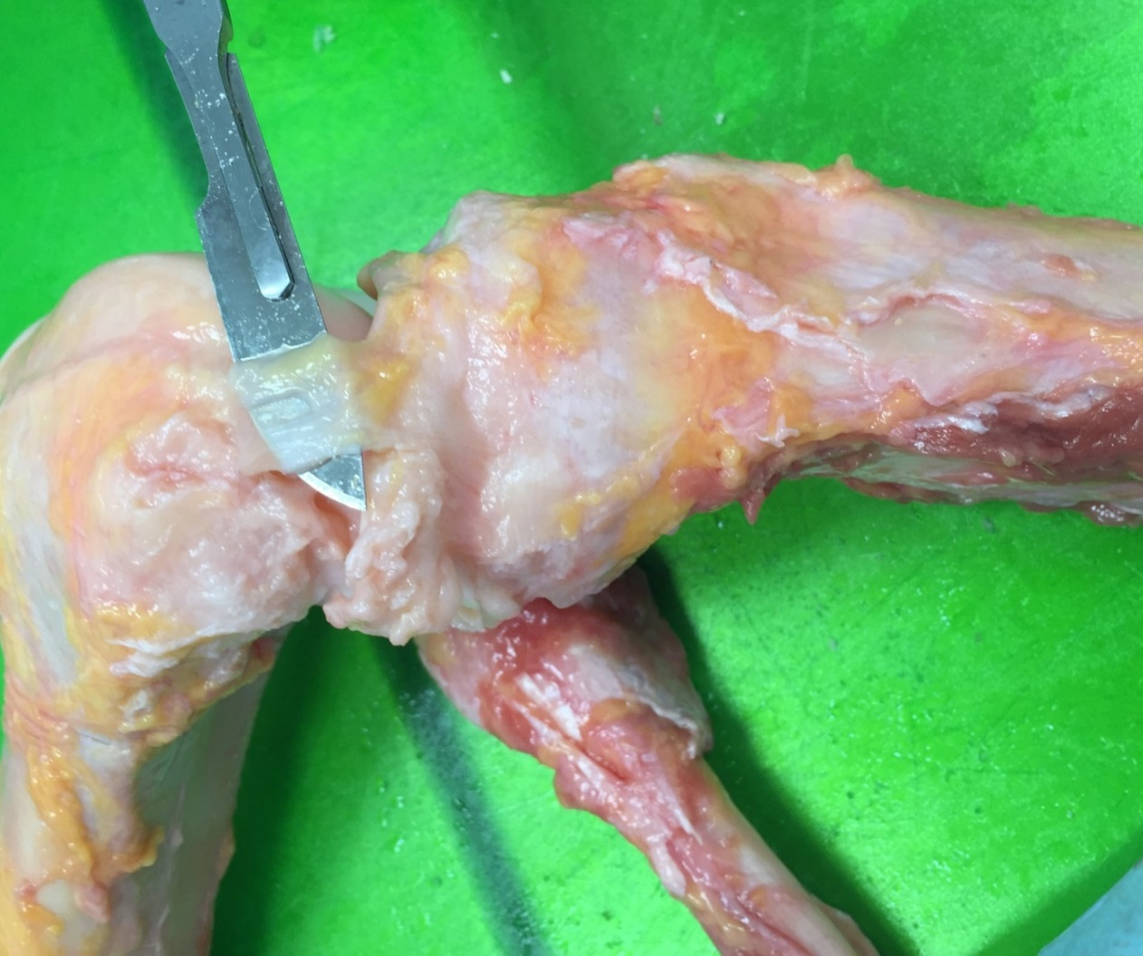
Fig. S1. A human medial collateral ligament from a young healthy donor that was severely abnormal, data from this ligament was excluded from statistical analyses.

ACL
PCL
MCL
LCL
ACL
PCL
MCL
LCL
ACL
PCL
MCL
LCL
ACL
PCL
MCL
LCL
ACL
PCL
MCL
LCL
Fig. S2. This figure shows the effect of age on material parameters of the anterior cruciate ligament (ACL), posterior cruciate ligament (PCL), medial collateral ligament (MCL) and lateral collateral ligament (LCL).

ACL
PCL
MCL
LCL

ACL
PCL
MCL
LCL
ACL
PCL
MCL
LCL

ACL
PCL
MCL
LCL

ACL
PCL
MCL
LCL
Fig. S3. This figure shows the effect of osteoarthritis (International Cartilage Repair Society (ICRS) Grading 0 to 4) on material parameters of the anterior cruciate ligament (ACL), posterior cruciate ligament (PCL), medial collateral ligament (MCL) and lateral collateral ligament (LCL).

Healthy knees (ICRS grade = 0) | OA knees (ICRS grades 1 to 4)

Healthy knees (ICRS grade = 0) | OA knees (ICRS grades 1 to 4)

Healthy knees (ICRS grade = 0) | OA knees (ICRS grades 1 to 4)

Fig. S4. Trends showing the effect of ageing in healthy and osteoarthritis (OA) cadaveric knees on the tensile properties of the anterior cruciate ligament (ACL), posterior cruciate ligament (PCL), medial collateral ligament (MCL) and lateral collateral ligament (LCL).

- Young healthy cadaver
- Old OA cadaver

Fig. S5. Example of load (N) against extension (mm) in the anterior cruciate ligament (ACL), posterior cruciate ligament (PCL), medial collateral ligament (MCL) and lateral collateral ligament (LCL) in (A) young healthy cadaver (31 years, grade 0), (B) old osteoarthritis cadaver (88 years, grade 3).

- Young healthy cadaver
- Old OA cadaver

Fig. S6. Example of stress (MPa) against strain (%) in the anterior cruciate ligament (ACL), posterior cruciate ligament (PCL), medial collateral ligament (MCL) and lateral collateral ligament (LCL) in (A) young healthy cadaver (31 years, grade 0), (B) old osteoarthritis cadaver (88 years, grade 3).

- Young vs old
- Healthy vs OA

Fig. S7. (A) Failure site in percentage of young (31-58 years) versus old (72-88 years) cadavers for anterior cruciate ligament (ACL), posterior cruciate ligament (PCL), medial collateral ligament (MCL) and lateral collateral ligament LCL). (B) Failure site in percentage of healthy (grade 0) versus osteoarthritis (grade 1 – 4) for the ACL, PCL, MCL and LCL.

